Module Six Exercise

Determine Key Risk Indicators

Michael Surdek
Southern New Hampshire University
DAT 610: Optimazation & Risk Assessment
Professor Kyle Camac
November 21, 2021
Introduction
A key risk indicator (KRI) is a measurement of a business factor that relates to an undesirable level of a particular risk. KRIs can be developed from three types of metrics: exception monitoring, which raise a flag when an exception occurs, lagging indicators, which track past activity and look for trends over time, and leading indicators, which attempt to predict points of emerging risk. (Girling, 2013) These metrics may be utilized to monitor internal and external risk factors or the risk control environment. “The goal of developing effective KRIs is to identify the relevant metrics that provide useful insights into potential risks that may have an impact on the organisation’s objectives.” (Pecek, 2019) Without alignment between KRIs and organizational objectives, risk management practices may not be focused on the factors that are most likely to have the large impacts on the business.
Data analytics can be leveraged to develop and monitor key risk indicators. Statistical analysis is a way to provide proof that certain metrics are associated with relevant risks that have been identified, ideally by a previously executed risk and control self assessment or analysis of internal and external loss data. Statistical methods such as principal component analysis and regression techniques can detect trends over time and provide contextual information for various risk areas.
Company XYZ can use these methods to analyze the Insurance Institute for Highway Safety dataset on insurance losses by car make and model. Some loss categories may serve as key risk indicators for overall insurance losses, which would allow Company XYZ to monitor its own risk profile and take corrective or preventative action if necessary. The goal of this analysis is to understand which insurance loss categories might be KRIs for determining lowest total average insurance loss for a particular automobile model.
Principal Component Analysis
The first statistical method that Company XYZ can use to develop KRIs is principal component analysis, which reduces the dimensionality of the IIHS dataset. Six components are created that represent combinations of the six insurance loss categories based on how much of the variance in the dataset that they account for. Since the categories are scaled to relative loss amounts, principal component analysis reveals the attributes that impact the overall risk of providing insurance based on a vehicle’s make and model. A principal component analysis model can be developed in R with the princomp function, and key elements of the model can be inspected with the summary function and by calling the loadings object.
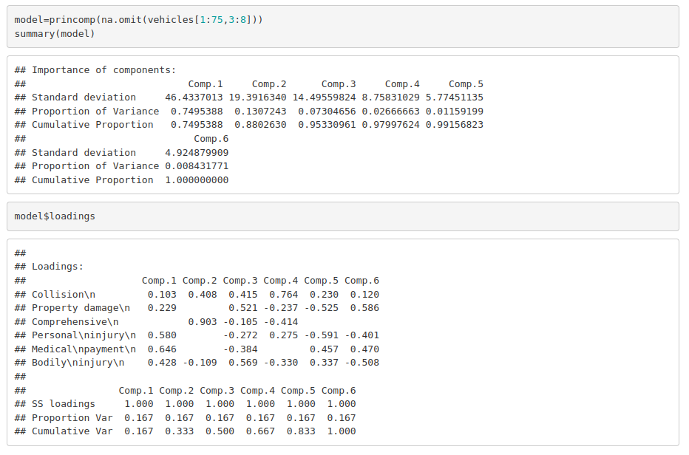
This summary of the PCA model shows that component 1 accounts for nearly 75% of the variance in the dataset and component 2 accounts for about 13%. Looking deeper into the model with the loadings object demonstrates how each of the six categories contributes to the first two components. Three attributes, personal injury, medical payment, and bodily injury, contribute to component 1, and one attribute, comprehensive, contributes heavily to component 2. This means that these four categories may be the best metrics for KRI development because the values of a vehicle make and model in these categories are associated with increased risk of overall insurance losses. For example, if a vehicle has a personal injury loss relative value of over 100, an exception could be triggered that results in an increased premium or even declining the insurance coverage altogether.
Linear Regression
Another statistical technique that Company XYZ can use to develop effective KRIs is linear regression, which analyzes how changes in the insurance loss categories contribute to changes in the overall risk levels of a vehicle make and model. In addition to identifying potential KRIs, “regression analysis is used to validate each KRI and to establish appropriate trigger levels..” (Immaneni, 2004) This means that linear regression can serve as proof that a certain metric is associated with increasing risk levels and it can help determine the point at which the factor would result in risk levels that should be avoided. In order to develop a linear regression model, there must be a target variable against which all other variables are analyzed. With the IIHS dataset, Company XYZ could use Average Loss as the target variable, but since that metric is relative to an average insurance loss score of 100, it is also possible to set the target variable as the binary outcome of the average loss being above or below 100.
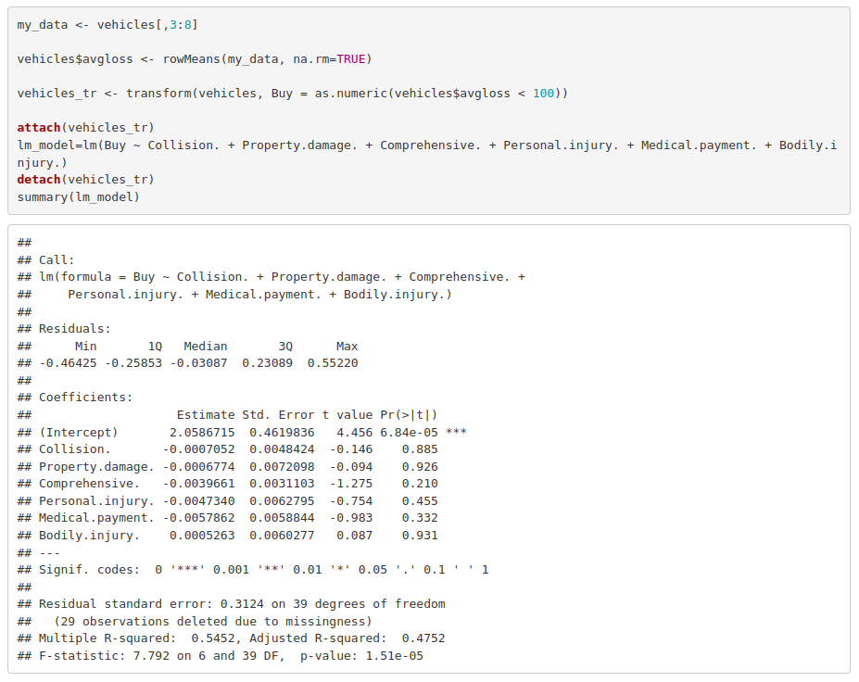
The summary of this linear regression model shows the estimates of how a one unit increase in each category impacts the value of the buy variable, which is either 0 or 1. For example, the medical payment has the largest estimated impact of -0.0058. Although it is not significantly different from an estimate of 0, it is clear that an increase in the value of medical payment insurance losses make the buy variable more likely to be 0 than 1. For this reason, Company XYZ may develop a key risk indicator based on the medical payment category. As an example, if they were unwilling to cover vehicles with an estimated buy value of 0.3, the linear regression analysis may result a threshold of the medical payment category at 134, which is equal to 100 + (0.3-0.5)/-0.0058.
Logistic Regression
Since the buy value is a binary outcome, linear regression is limited by its ability to analyze the target as a continuous variable. On the other hand, logistic regresion is a similar method that handles the likelihood of discrete outcomes. What this means is that instead of the estimates showing how a change in an independent variable impacts the buy value ranging from 0 to 1, logistic regression estimates will show how the change impacts the likelihood of the buy value being either 0 or 1.
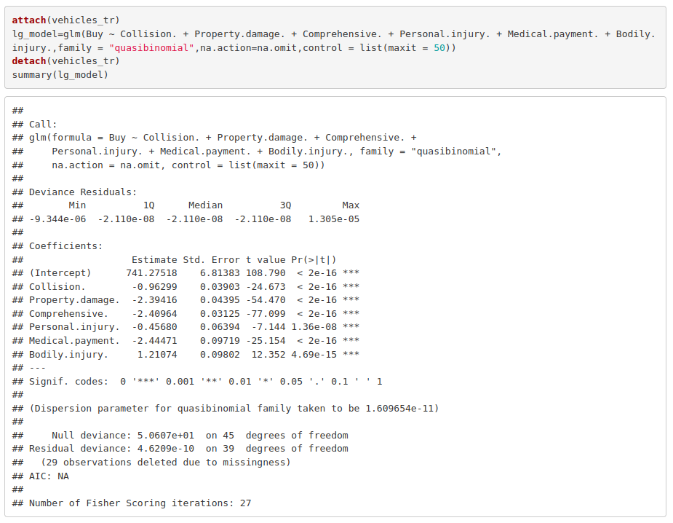

The summary of this logistic regression model shows the estimates of how a one unit increase in each category impacts the likelihood that the buy variable is either 0 or 1. For example, a comprehesive relative insurance loss value of 101 results in a 2.4% decrease in the likelihood of a buy value of 1 versus an average vehicle. All of the estimates from the logistic regression are statistically significant at the 0.001 level, meaning that changes in each category result in a change in the likelihood of a 1 buy value that is significantly different than 0. Company XYZ can use this model to develop key risk indicators in a similar way to the linear regression model. If they used logistic regression to establish the threshold for the medical payment category where the likelihood of a 1 buy value is not less than 30%, the threshold could reasonably be set at 108, which is 100 + (0.3-0.5)/.024471.
Conclusion
Data analytics can be leveraged to develop effective KRIs by using statistical methods that provide evidence for determining important metrics and the thresholds that should be set. Principal component analysis reveals at least four metrics that account for most of the variance in the IIHS dataset. Linear and logistic regression analyze the relationships between each insurance loss category and a buy variable that represents an average loss of more or less than 100. Since Company XYZ hopes to improve their insurance coverage risk profile, data analytics can guide their decisions based on particular vehicles and how their historical insurance losses contribute to the chances that future losses will reach undesirable levels.
References

Girling, P. X. (2013). Operational Risk Management: A Complete Guide to a Successful Operational Risk Framework. Wiley Professional Development (P&T). Retrieved from https://mbsdirect.vitalsource.com/books/9781118983430

Immaneni, Aravind. Mastro, Chris. Haubenstock, Michael. (2004). A Structured Approach to
Building Predictive Key Risk Indicators. RMA University. Retrieved from https://cms.rmau.org/uploadedFiles/Credit_Risk/Library/RMA_Journal/ Operational_Risk_Topics/A%20Structured%20Approach%20to%20Building%20Predictive %20Key%20Risk%20Indicators.pdf

Peček, Bojan & Kovačič, Andrej. (2019). Methodology of monitoring key risk indicators. Economic Research-Ekonomska Istraživanja. Retrieved from https://www.tandfonline.com/doi/full/10.1080/1331677X.2019.1658529? scroll=top&needAccess=true

